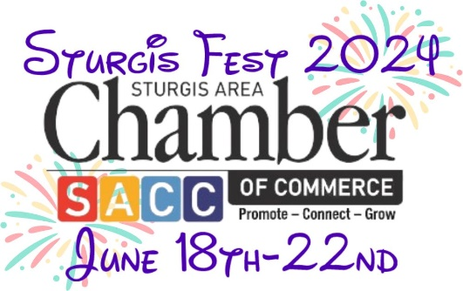

STURGIS AREA CHAMBER OF COMMERCE
STURGIS ELECTRIC PARADE POLICY
Friday, June 21st, 2024
(This policy MUST be signed and returned)
PARADE DEADLINE OF SUBMITIONS: MONDAY, JUNE 10TH, 2024

Parade policy will allow all entries to participate at NO CHARGE. That is: marching units, floats, military units, walking parade units, comedy entries and rolling units. All entries MUST BE lit. Political campaigns may be accepted for a $100 fee.

With the exception of parade leadoff vehicles, all fire trucks, ambulances, police cars, and like vehicles are not permitted to sound horns or sirens (lights may flash) during the parade due to horse entries, band entries and safety reasons. When your unit is announced at the Judges’ stand you may sound sirens in recognition of your unit. This also applies to vehicles with loud exhausts.

ALL ENTRIES ARE SUBJECT TO THE APPROVAL OF THE PARADE CHAIRS.

Please read through the following and initial to indicate your understanding and agreement.

DO NOT THROW CANDY, TRINKETS OR ANY ITEMS INTO THE CROWD FROM YOUR MOVING VEHICLE OR FLOAT DURING THE PARADE. POLICE OFFICERS WHO OBSERVE THIS ACTIVITY WILL HAVE THE AUTHORITY TO IMMEDIATELY DIRECT YOUR VEHICLE OUT OF THE PARADE. PLEASE HELP US AVOID A SERIOUS ACCIDENT CAUSED BY CHILDREN RUNNING TOWARDS YOUR MOVING VEHICLE. (However, a walking distributor may pass items out ALONG THE CURB.)
______

No one under the age of 18 shall be allowed to operate the following:
______
- Motorized Vehicles (including cars, trucks, vans, buses, etc.)
- Mobile Equipment (including farm equipment, tractors, side-by-sides)
- Motorcycles/ Recreational Vehicles (including 4-wheelers, dirt bikes, etc.)
______
If your driver is driving a personal vehicle that is representing your company, please provide the following:
(We MUST have these on file to allow participation)
- A valid driver’s license (mandatory)
- Proof of personal auto insurance (mandatory)
- Non- owned auto liability through the company

If you or your driver is driving a personal vehicle not associated with a company, please provide the following:
______
(We MUST have these on file to allow participation)
- A valid driver’s license (mandatory)
- Proof of Personal auto Insurance (Mandatory
  - If applicable- Antique/ Classic Car Insurance

If your driver is operating a corporate provided vehicle, please provide the following:
______
(We MUST have these on file to allow participation)
- A valid commercial license if required to operate the vehicle/valid driver’s license (mandatory)
- Commercial Auto liability insurance
  - Check this circle if this does not apply to your float entry (no need to initial if this does not apply)
THANK YOU!
STURGIS POLICE DEPARTMENT

I have read and I understand this policy.

Signature_____________________________________ Date___________________

Representing _______________________________________which is applying as an entry in the Sturgis Electric Parade 2024.

PARADE DEADLINE OF SUBMITIONS: MONDAY, JUNE 10TH, 2024

STURGIS ELECTRIC PARADE ENTRY FORM 2024

PARADE DEADLINE OF SUBMITIONS: MONDAY, JUNE 10TH, 2024

Return to:
STURGIS ELECTRIC PARADE

C/O STURGIS AREA CHAMBER OF COMMERCE
306 W. Chicago
STURGIS, MI 49091

This year’s theme is “Disney Days”

______We will enter a FLOAT:_______of our own making_______commercially made
Float Length:___________feet --- Vehicle Length:________________feet
_____Our entry has music.

______We will enter the following (please circle): BICYCLES, MARCHING UNIT, HORSE UNIT (please indicate if a pooper scooper is needed, charge is $15 if we supply one. If one not requested, you must supply your own or you will be invoiced for cleanup), SHRINE UNIT, ANTIQUE VEHICLE, VEHICLE CLUB.

______Other:___________________________________________________________________________

***TOTAL FOOTAGE of entry (if not stated above):_____________________feet. This information is very important and needed to do the parade line-up. Entry will
not be permitted in the parade without this information!

Name of Organization:___________________________________________________________________

Contact Person: _________________________________________________________________________

Mailing Address: _______________________________________________________________________

City, State & Zip Code: __________________________________________________________________

Telephone: ____________________________________________________________________________

E-Mail________________________________________________________________________________

FOR MC TO ANNOUNCE DURING PARADE:

AWARDS RECEIVED: _________________________________________________________________

_____________________________________________________________________________________

OTHER INFORMATION: _______________________________________________________________

_____________________________________________________________________________________

_____________________________________________________________________________________

